Latency Track Nvidia Stack
- What is the biggest adoption barrier for GlobalWear’s EcoThread products? (Semantic)
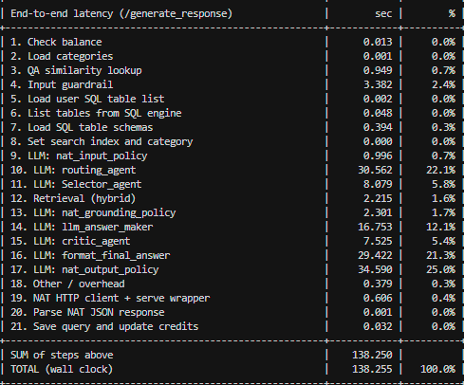
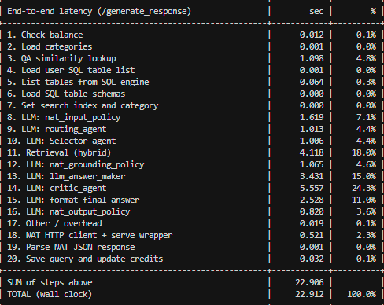

- What were the key consequences of the delay for Zenith Apparel’s European operations? (Semantic)
- 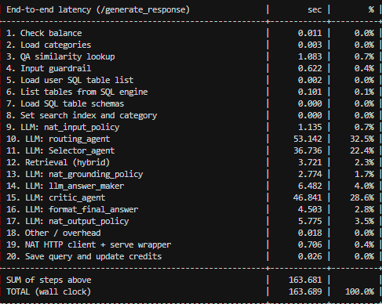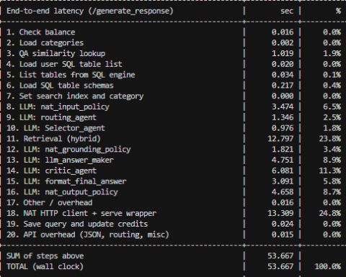

- Calculate the total gross profit (Revenue_USD - COGS_USD) generated by the Gen Z customer segment across all regions. (SQL)
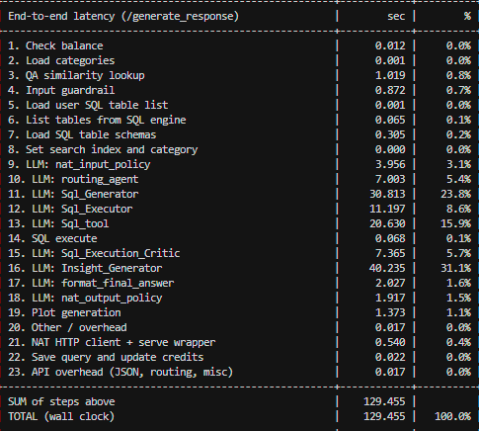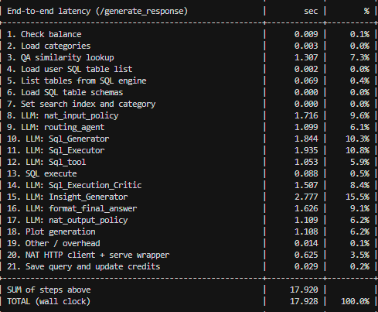
- What is the total revenue generated by each retailer across all regions? (SQL)
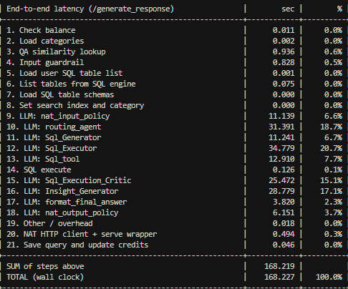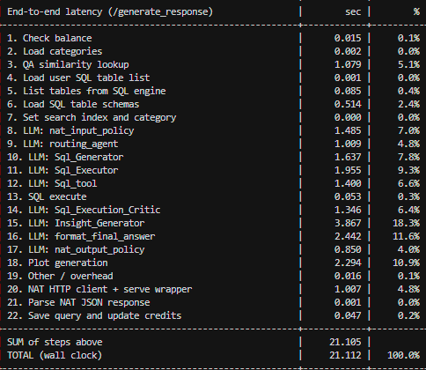

1. Production-Grade Support & Stability
- Dedicated Support: Access to direct NVIDIA experts, guaranteed SLAs, and long-term support (LTS) branches so mission-critical AI systems do not break during critical operations.
- No Model Drift: Raw open-source repositories update constantly, which can cause unexpected breaks. Enterprise models are curated and pre-tested to behave predictably in production.
2. Maximum Hardware Optimization
- Out-of-the-Box Speed: Enterprise deployments use pre-built inference microservices like NVIDIA NIM , which bake in highly optimized engines (eg, TensorRT-LLM and Triton Inference Server).
- Superior TCO: These engines are pre-configured for aggressive KV-cache management, paged attention, and lower-latency processing (eg, FP8/NVFP4), allowing businesses to do more with less expensive GPU hardware.
3. Streamlined Security and Compliance
- CVE Patching: Free open-source distributions require your team to continuously monitor for Common Vulnerabilities and Exposures (CVEs) and patch them manually.
- Regulatory Readiness: Enterprise packages offer built-in regulatory compliance (such as FedRAMP readiness), secure model weights, and the ability to set strict guardrails that block harmful content and protect PII.
4. Standardized Integration (NIMs)
- OpenAI-Compatible APIs: NIM microservices present models using industry-standard API formats ( /v1/chat/completions). This eliminates weeks of engineering time spent stitching together runtimes or rewriting application code, allowing seamless integration into existing corporate workflows.
- Portability: Containerized microservices can be deployed uniformly across any NVIDIA-accelerated environment—from data centers to local RTX AI PCs. [1, 2, 3]
5. Domain-Specific Customization
- Pre-packaged Frameworks: Enterprise tools (like NVIDIA NeMo ) provide the building blocks to fine-tune and customize models securely using your organization's proprietary data for specialized domains like healthcare (BioNeMo) or creative workflows.

